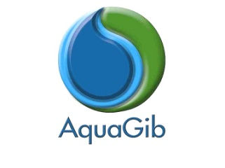

AquaGib Ltd invites applications for the post of Semi-Skilled Operative within our Water Networks Department.

If you are interested in working within the water industry, in a professional organisation dedicated to providing the best possible service to our customers, then you could be a potential candidate to join our frontline team.

Application forms and details of the post can be viewed online at http://www.aquagib.gi or collected from our Main Office at Suite 10B, Leanse Place, 50 Town Range. The completed forms should be submitted to our Administration Manager at our Main Office or by email to administration@aquagib.gi by no later than Friday 4 September 2026.

